payment plans – cashier receives payment from student
business process: accounts receivable
Module: STUDENT financials

prerequisites
- Student must be enrolled in a Payment Plan and have a balance due. [NOTE: Minimum amount balance due is REQUIRED to enroll in a Payment Plan. The current minimum amount is $250.00. However, this amount is subject to change.]

instructions

This Job Aid illustrates how the Accounting Cashier enters a payment for a student’s Payment Plan (Cashier’s POV).

STEP | Instructions
1) | Login to myportal.sdccd.edu. Cashier enters his/her “User ID” and “Password”, and then clicks “Sign In”.
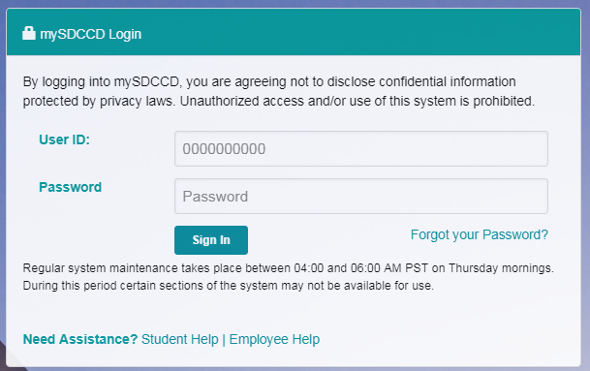
STEP | Instructions
2) | Click [] then [] and navigate to Campus Solutions > Student Financials > View Customer Accounts…
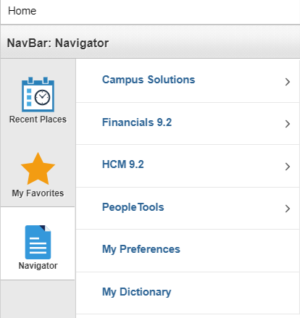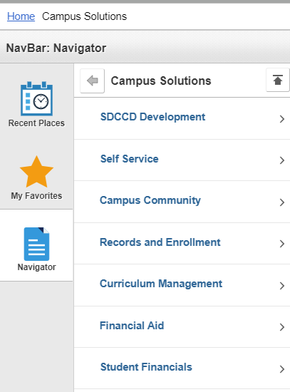
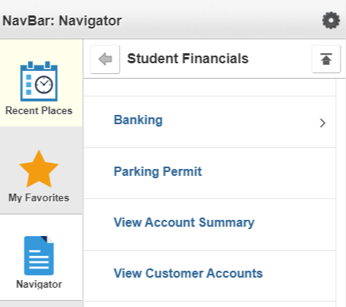

STEP | Instructions
3) | Enter the Student’s ID# into the “ID” field. Click “Search”.
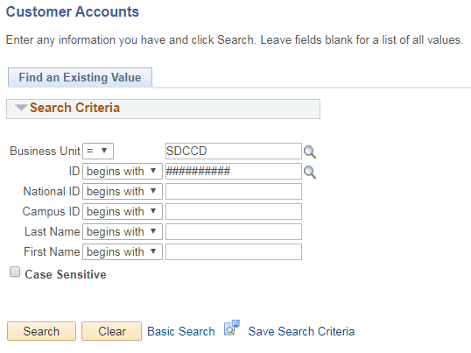

STEP | Instructions
4) | Confirm student is enrolled in a Payment Plan and has a balance due. Look for “PLN” in the Account Type column.
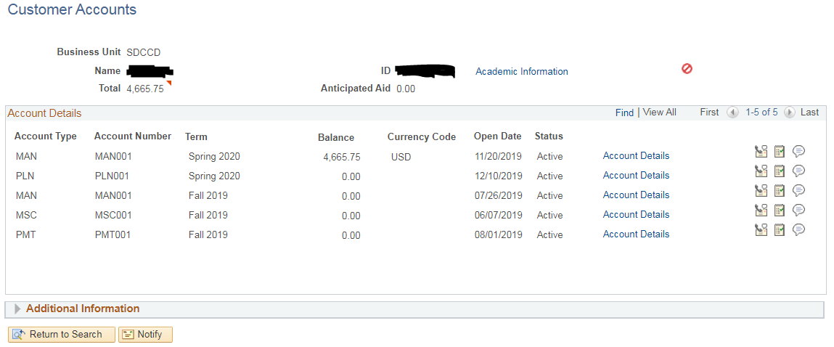

STEP | Instructions
5) | Login to TouchNet to see the details of the student’s Payment Plan.
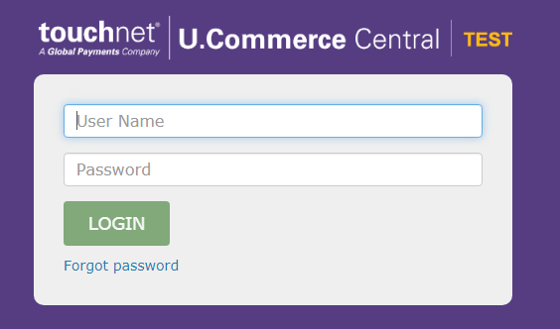

STEP | Instructions
6) | Click Applications
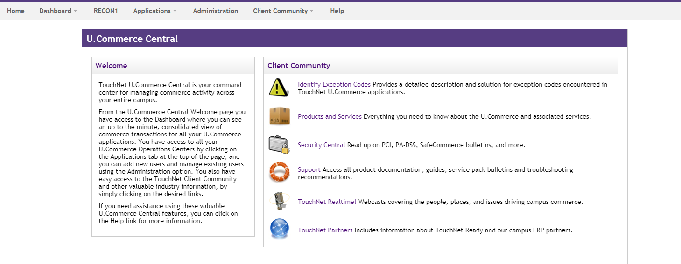

STEP | Instructions
7) | Click “Bill+Payment”
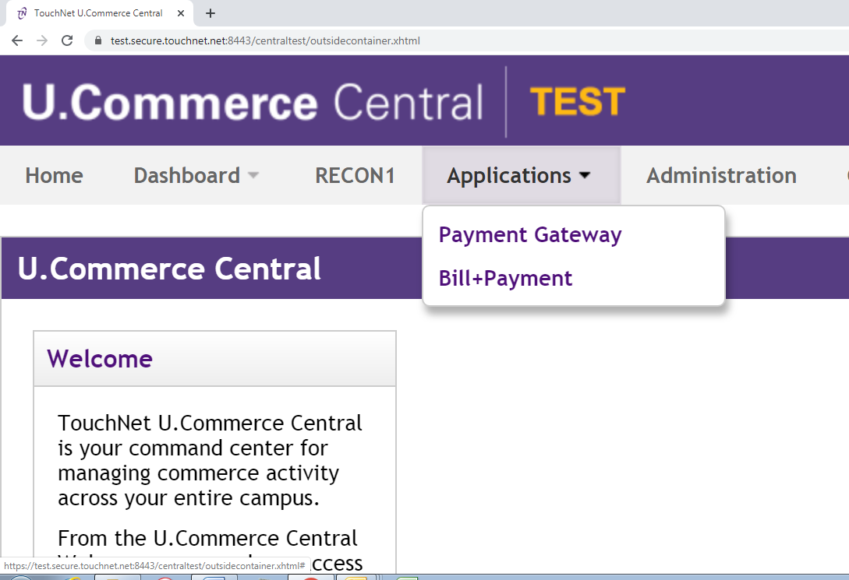

STEP | Instructions
8) | On the left side of the screen, enter the Student’s ID into the “Student ID” field, then click “View”
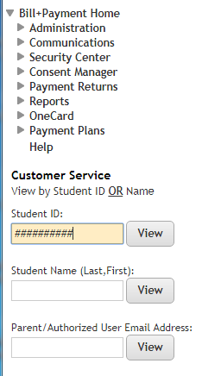

STEP | Instructions
9) | Click the “View” link in the “Action” column to see a breakdown of the student’s due payments.

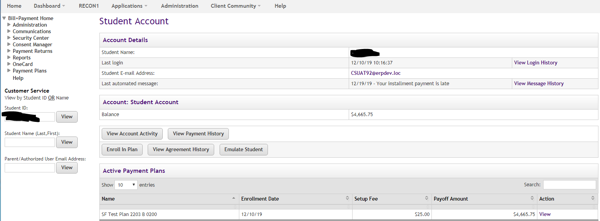

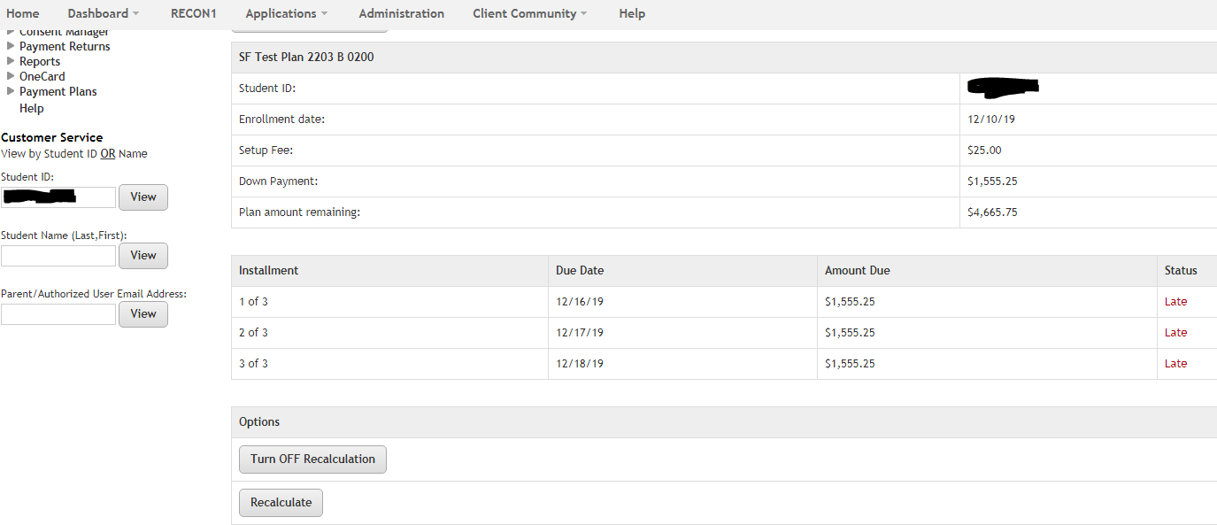

STEP | Instructions
10) | To enter a student’s payment, go back to Campus Solutions in PeopleSoft and navigate to Campus Solutions > Student Financials > Cashiering > Post Student Payments…

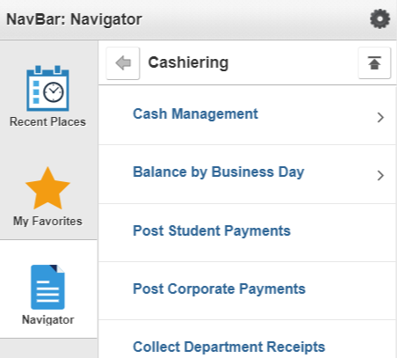

STEP | Instructions
11) | Enter the appropriate “Cashier’s Office” and “Student’s ID#”, and then click “Add”.
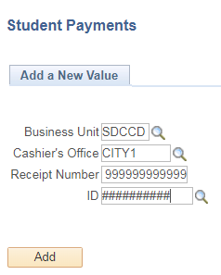

STEP | Instructions
12) | In the “Target Detail” section, enter the appropriate information in the “Target”, “Amount”, and “Term” fields. In the “Tender Detail” section, enter the appropriate information in the “*Tender” and “Amount” fields.  Click “Create Receipt”.
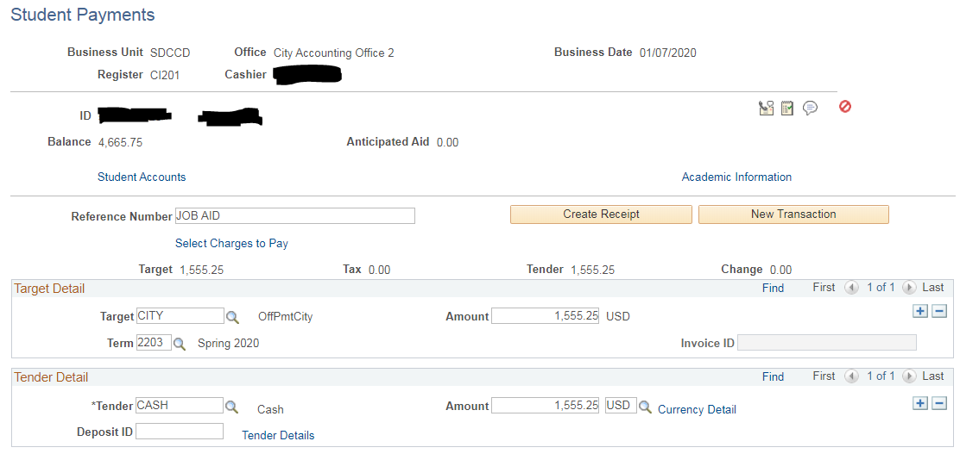

STEP | Result
13) | Return to TouchNet to confirm the payment has gone through and to recalculate the student’s Payment Plan. In the “Active Payment Plans” section, click the “View” link.
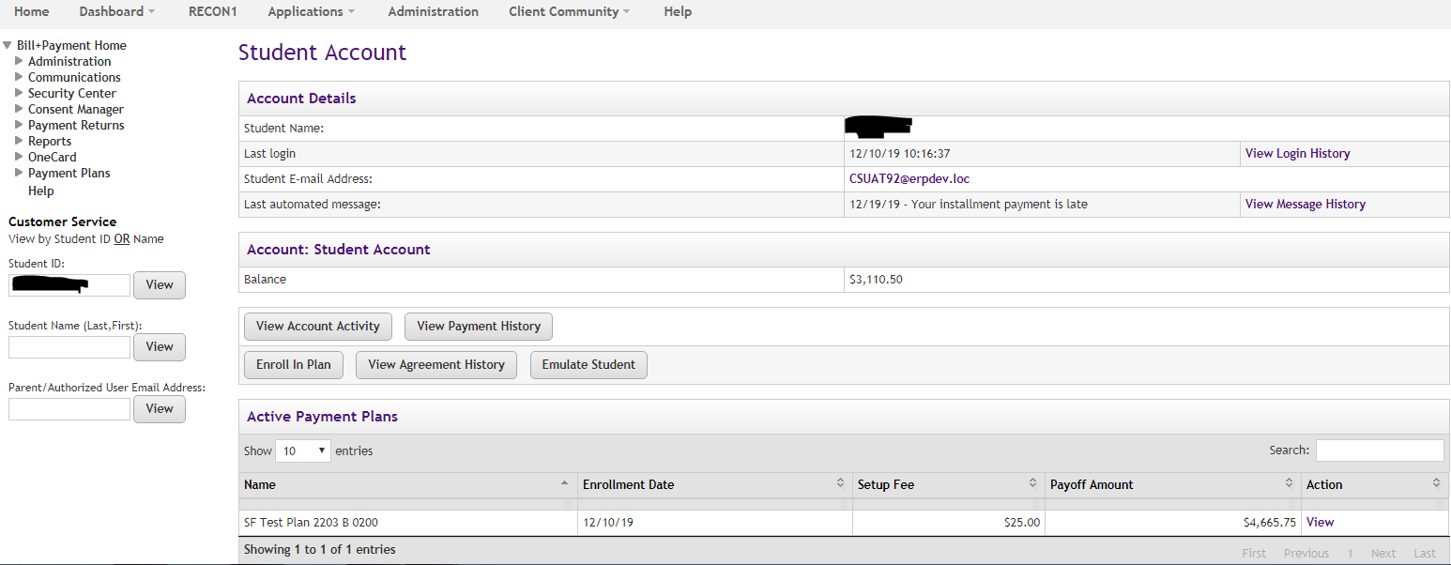
STEP | Result
14) | Click “Recalculate” to recalculate the Payment Plan.
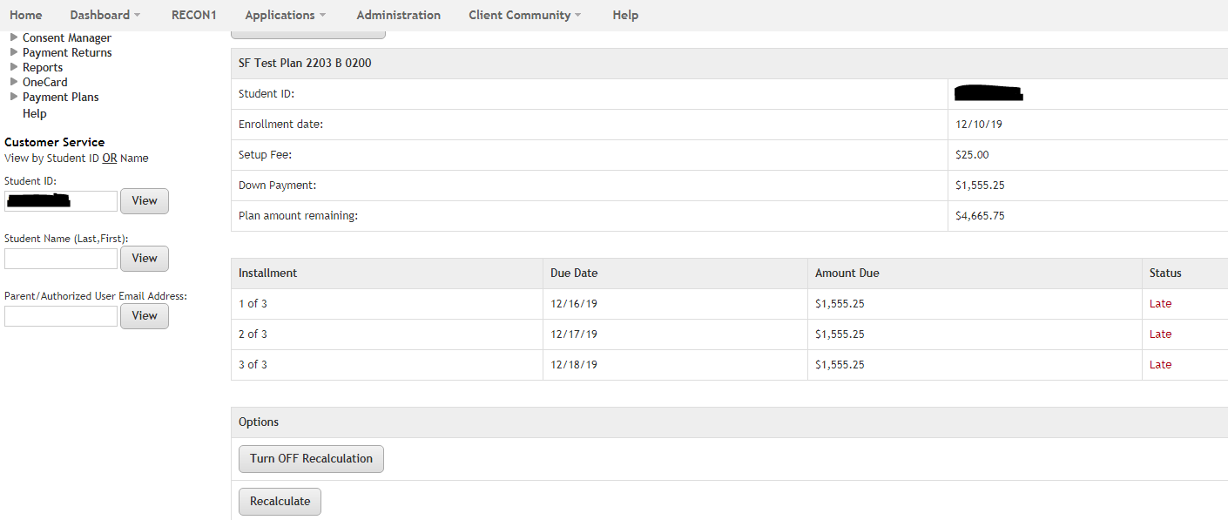

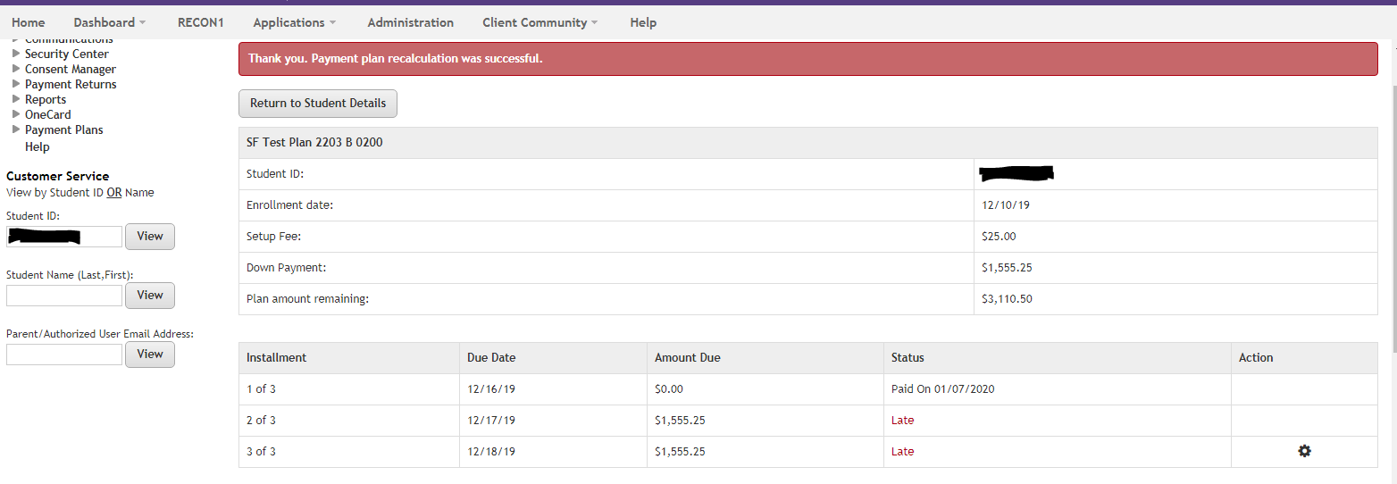

End of Procedure

