FEE TRANSFER
business process: cHANGE OF COURSE LEVEL WITHIN A DISCIPLINE OR SCHEDULE ADJUSTMENT AFTER DROP DEADLINE
Module: STUDENT RECORDS

prerequisites
Student must be enrolled in course and fees paid for that course. Student must have approved petition with all signatures. After the withdrawal deadline, all fee transfers must be petitioned through the Vice President, Student Services.

instructions

This Job Aid will go over the process to drop a student from one class and add them to another class, and to transfer the fees paid to the added class.

STEP | Instructions
1) | Use Enrollment Request Search to look up when the class was added. You will need this information later in the process.  Click on and navigate to Records and Enrollment-> Enroll Students > Enrollment Request Search

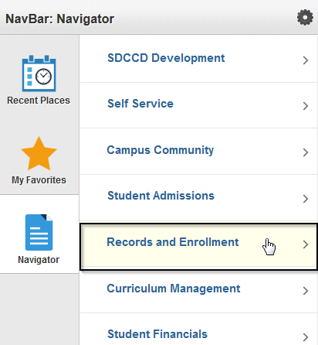 | 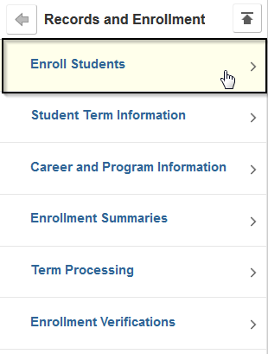 | 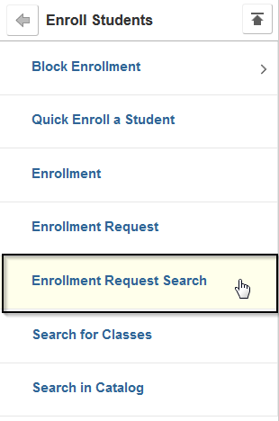

Step | Action
2) | If prompted, enter SDCCD for Academic Institution.
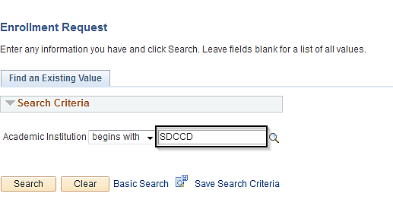
Step | Action
3) | Enter data in these fields:  Academic Career: Select Undergraduate  Term  ID: Student’s 10-digit ID number  Class Nbr: If you have this, it is helpful, but not necessary  Click Search
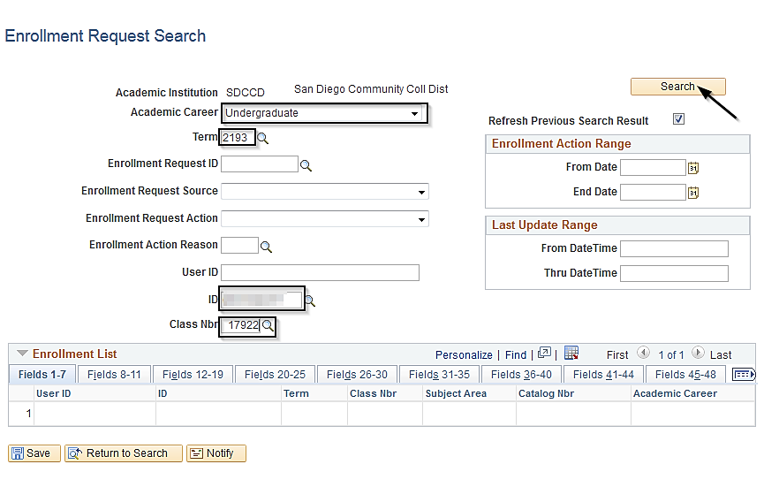
Step | Action
4) | Locate the line of the transaction where the student enrolled in the class.  On the Fields 12-19 tab, find the Enrollment Action Date.
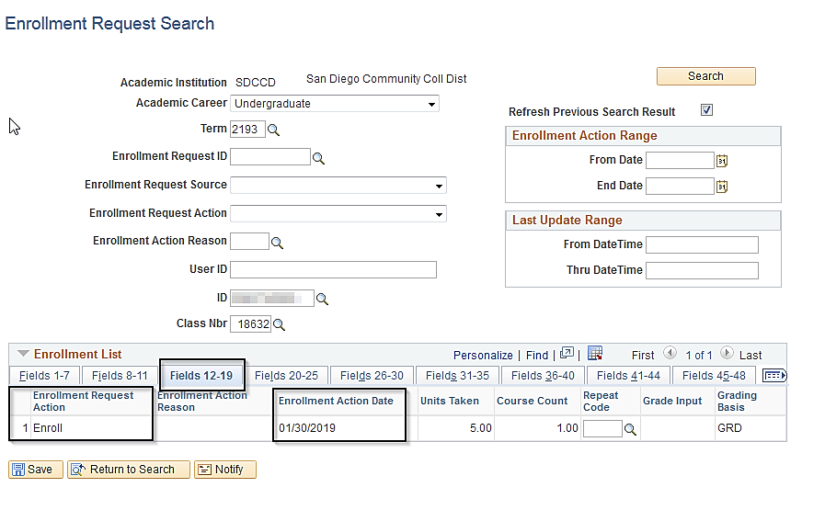
Step | Action
5) | Open a new window. (Keep the Enrollment Request Search available to refer to later.)  In new window, navigate to Quick Enroll a Student

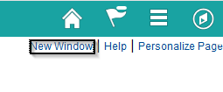 | 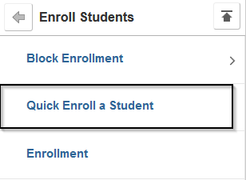

Step | Action
6) | Select Add a New Value tab.  Enter student’s ID and the Term  Click Add

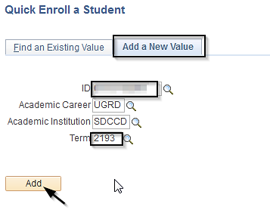
Step | Action
7) | On the Class Enrollment Tab  Click the + on the left to add a new row so that you have two rows to work with.  On the top row select Drop in the Action field.  The Action for the second row will default to Enroll.
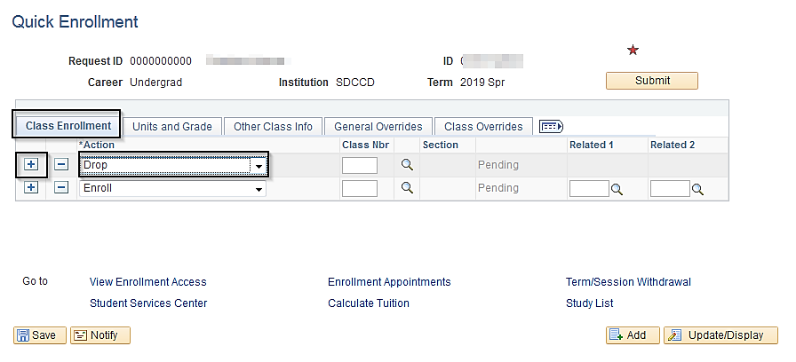

Step | Action
8) | Enter the class number for the class to be dropped on the top line and the class to be added on the bottom line.  Tab out of the field and the subject and catalog number for the class will display.  If you do not have the class numbers, use the search function to select the classes.

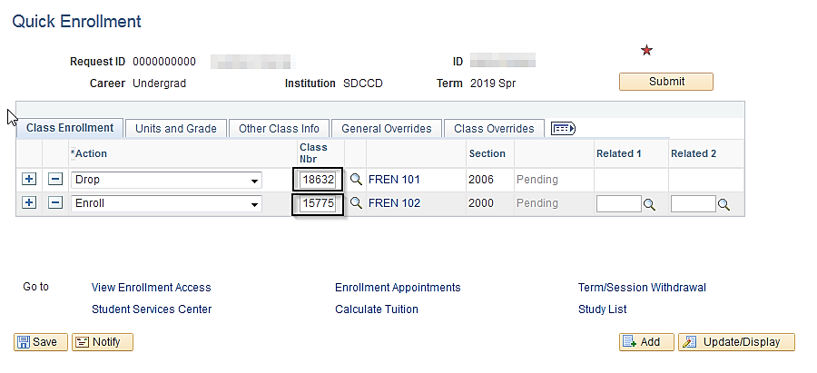

Step | Action
10) | Go to the Other Class Info tab  Select Action Reason: XDRP for class to be dropped (first line)  Select Action Reason: XADD for class to be added (second line)  Note: Since you have already selected the Action to be performed on each class, the Action Reason field will only allow you to select from the “Drop” Action Reasons for the drop class, and the “Enroll” action reasons for the add class.
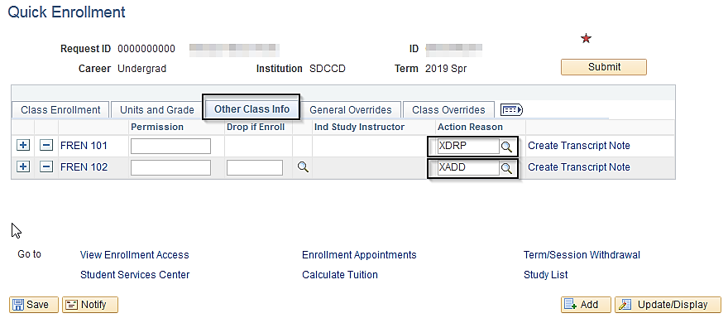

Step | Action
11) | Go to the General Overrides tab, and check the Action Date checkboxes for both classes.  Determine whichever of these dates is later, and enter as the Action Dt for both classes.  - The first day of the session, or  - The date the student enrolled in the class  In other words, if the student enrolled in the class on or before the first day of the session, enter the date of first day of the session. (To find the first day of the session, click on the hyperlink of the class subject/number to view Class Details.)  Or  If the Enrollment Action Date you viewed in Step 4 is later than the start date of the class, use that date.  This is necessary because Campus Solutions will not allow the Action Date of the Drop to pre-date the Enroll, i.e. you can’t drop the class before it was added.  In this example, the class began on 01/28/2019, but the student added the class on 01/30/2019. Use the later date, 01/30/2019.
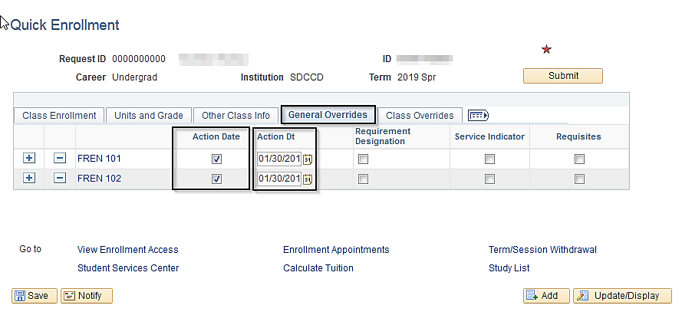

Step | Action
13) | If the student is moving from a lower level to a higher level class in the same discipline:  On the General Overrides tab, check the Requisites box for both classes.

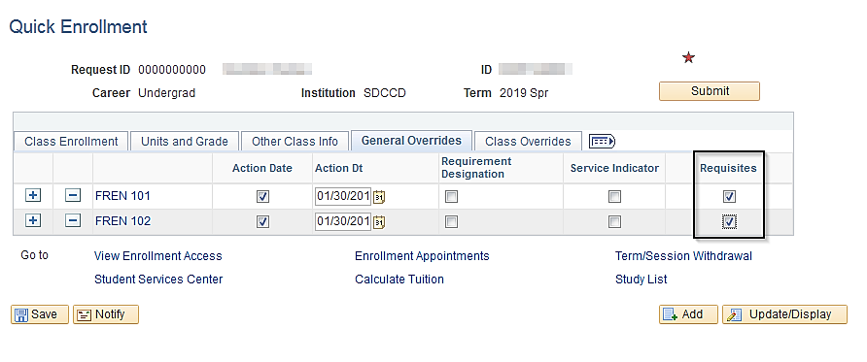

Step | Action
14) | Go to the Class Overrides tab.  For the class being added, check the box for Class Permission, and if applicable, Closed Class.  Click Submit.

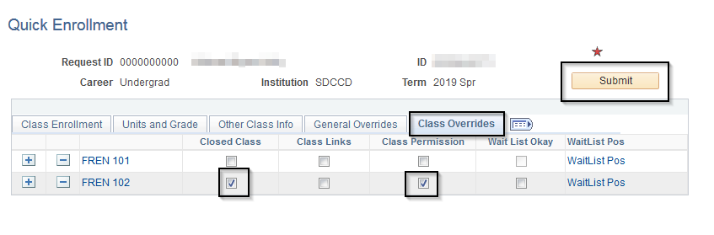
Step | Action
14) | Once processed, the transactions will display “Success,” “Message,” or “Error.”

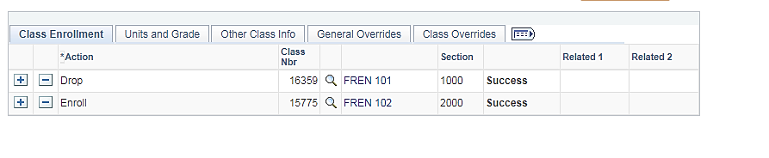
Step | Action
15) | Open a new window.  Navigate to Person Comments:  Campus Community > Comments > Comments – Person > Person Comment Entry  Add a new value.
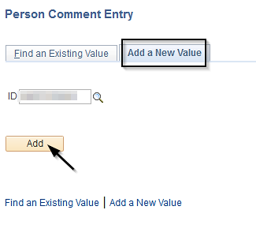

Step | Action
16) | Enter:  Administrative Function: GEN  Comment Category: Choose the code that matches your campus and department.  Comments:  Line 1: TERM XDROP Subject Catalog Number/Class Nbr XADD Subject Catalog Number/Class Nbr  Line 2: “Effective Date” Here, indicate the correct effective date of the move, as indicated on the petition on the “First Day of Attendance” line.  See example below.
