Validating vaccine cards in Cleared4 (Biocept)

instructions
STEP | Instructions
1) | Log into Cleared4/Biocept (https://client.cleared4.org/login).

STEP | Instructions
2) | Click on “Users” on the left panel.

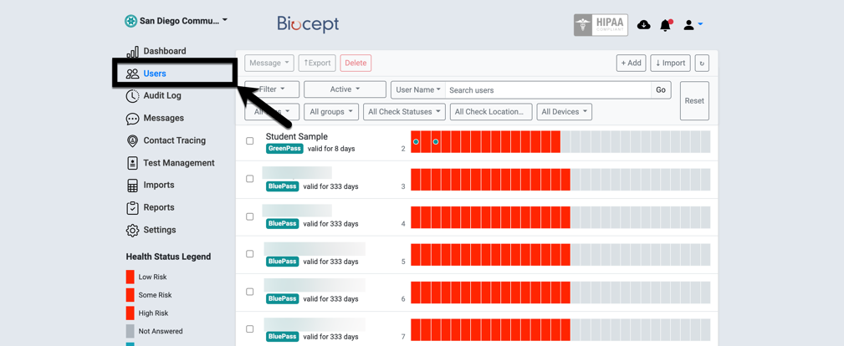

STEP | Instructions
3) | Click on “Reset” to clear all previous filters.

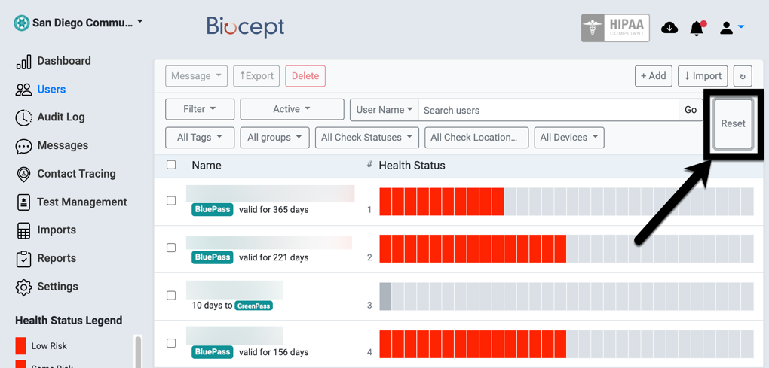

STEP | Instructions
4) | Click on “All Tags” to select your campus. In this example, let us use City College.  Click on “city students”.

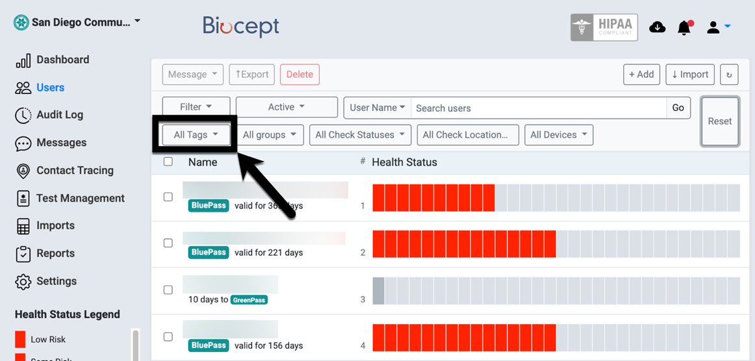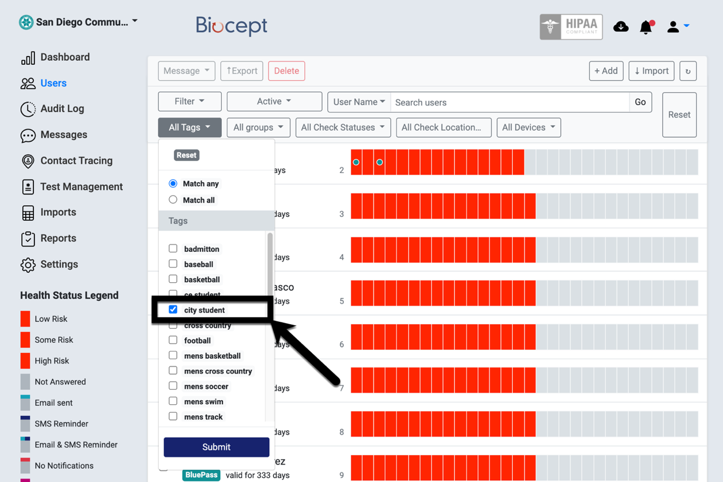
STEP | Instructions
5) | Click “Submit”.
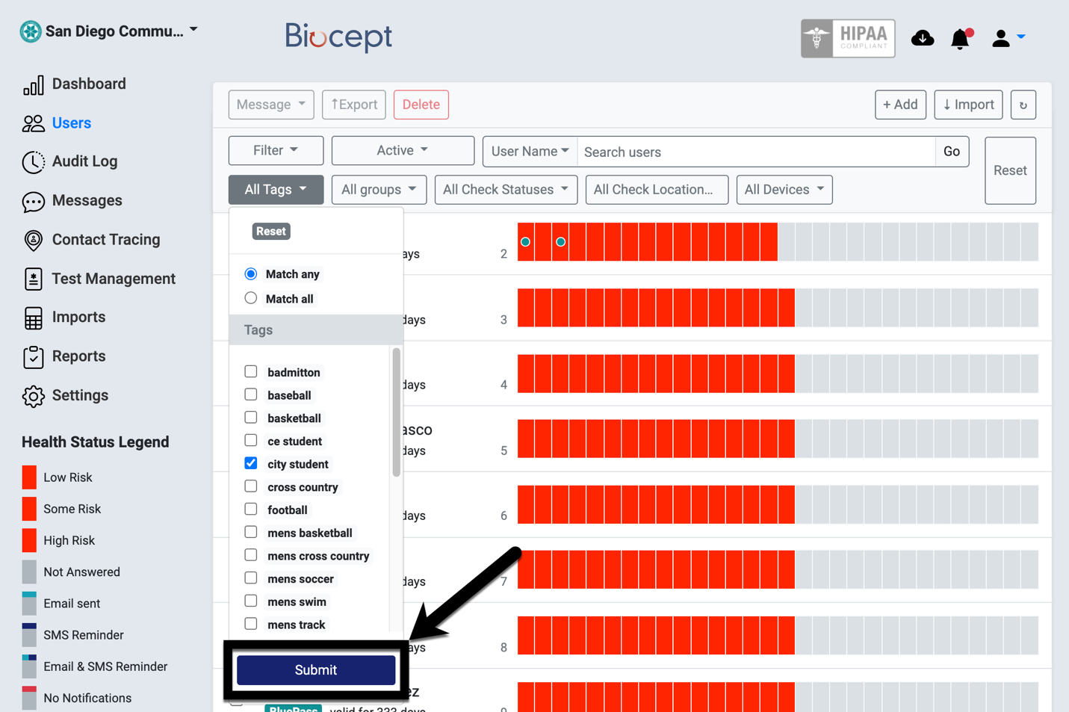

STEP | Instructions
6) | You should see that “city student” is now filtered in the result.
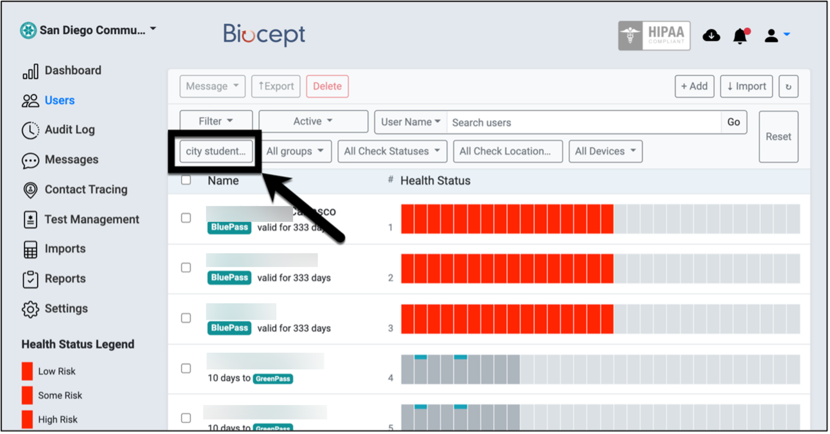

STEP | Instructions
7) | Click on “Filter” to select “Pending Vaxs”.
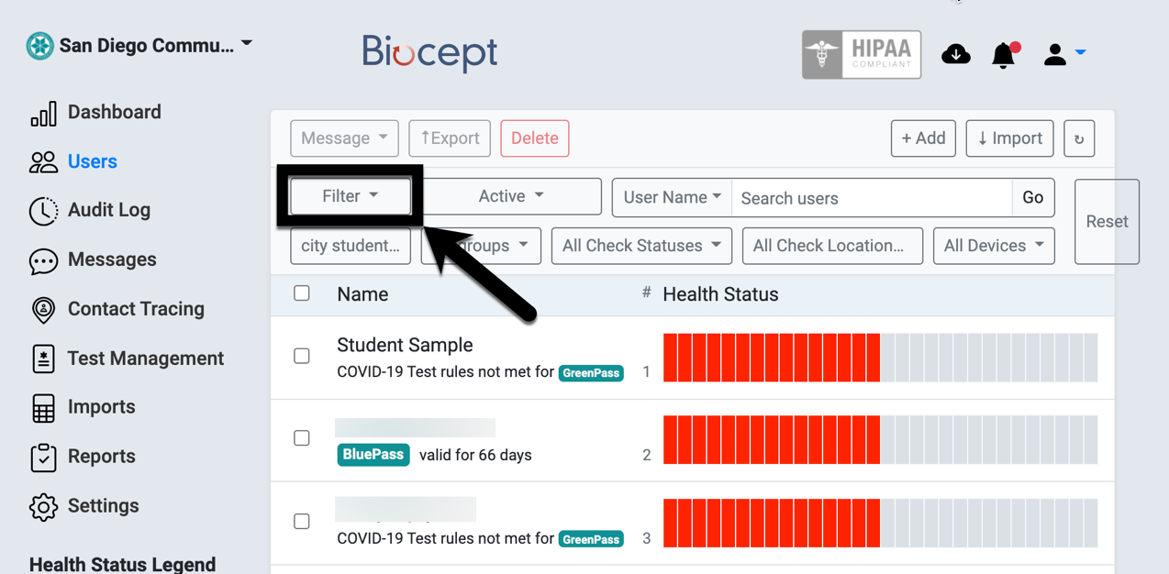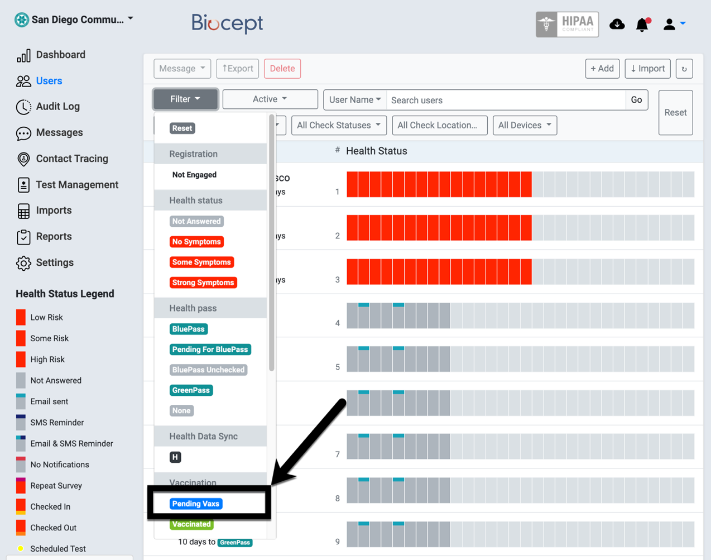
STEP | Instructions
8) | Your results now show City College students that have pending vaccination cards to be validated.

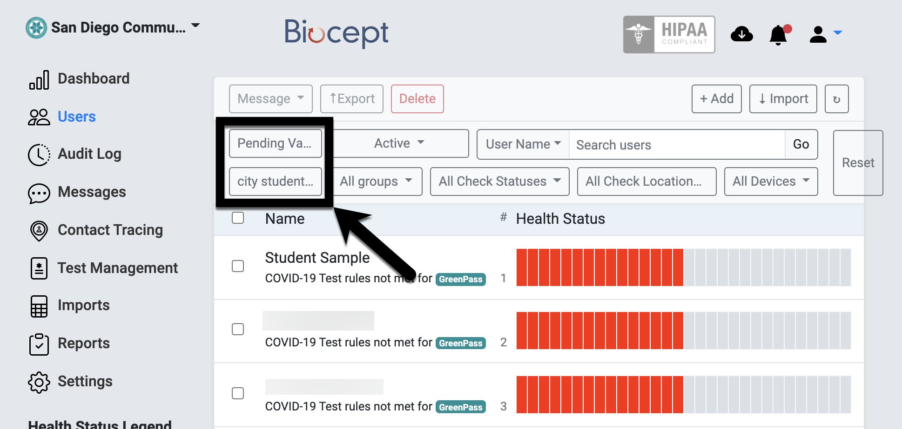
STEP | Instructions
9) | Start validation by clicking on the first student that does not have a “BluePass”.  Note: “BluePass” = Fully-Vaccinated; “GreenPass” = Tested negative for this week.
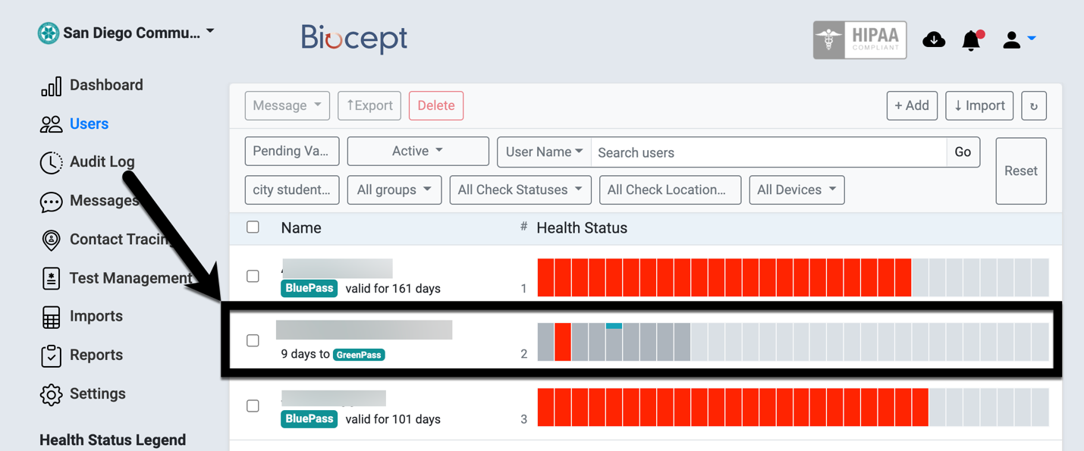
STEP | Instructions
10) | Scroll to “Vaccination Information”. Notice that there are two rows of “Vaccination Proof” that are “Pending”.
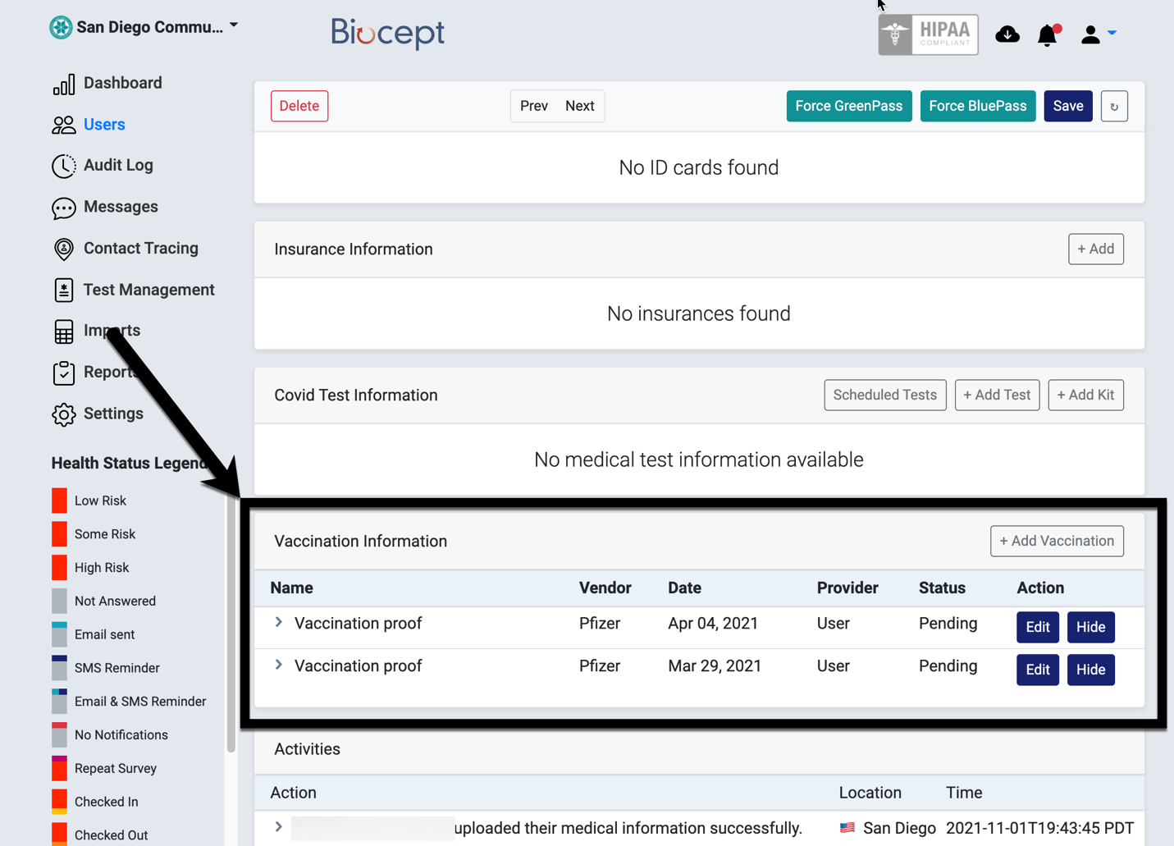

STEP | Instructions
11) | Start with the lowest row (earlier date) – Mar 29, 2021. Click on Edit.
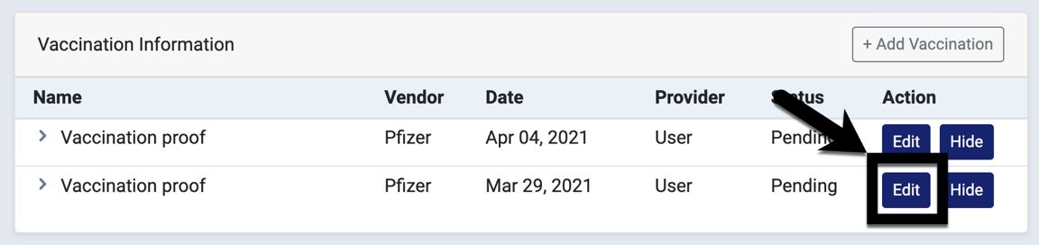
STEP | Instructions
12) | Validate the student’s information, vaccination name, date taken, etc. In this example, Dose 1 is Pfizer and was given on 03/29/2021. This matches with 1st Dose on the Vaccination Card.
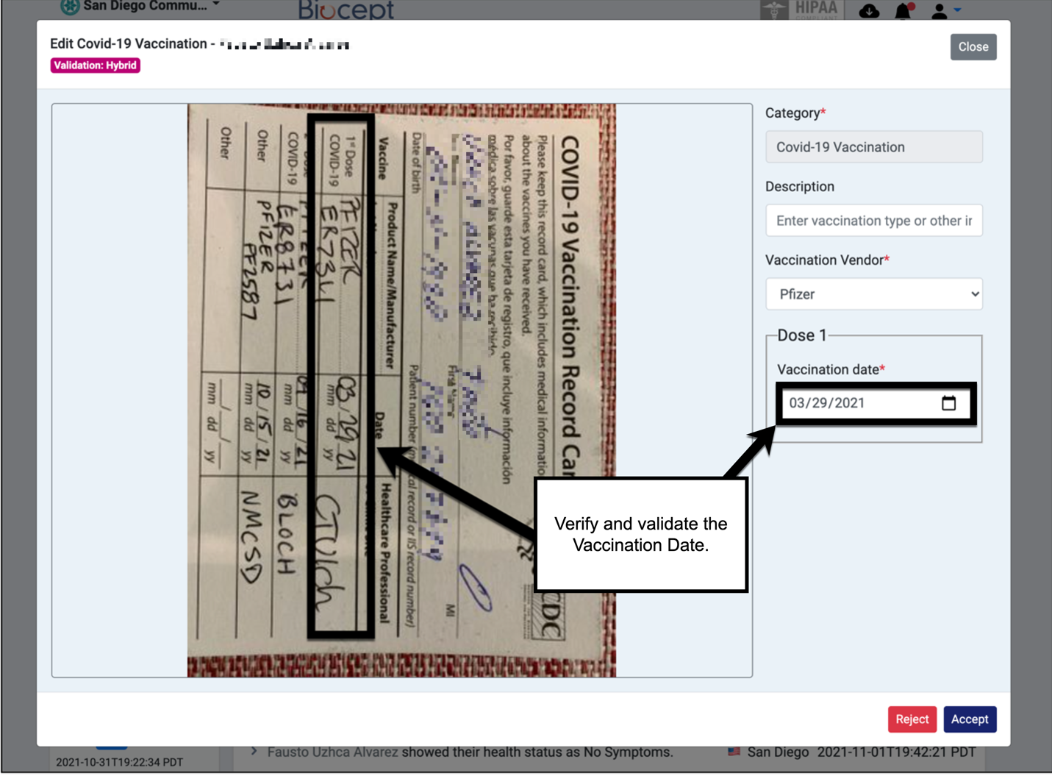

STEP | Instructions
13) | Click “Accept”.
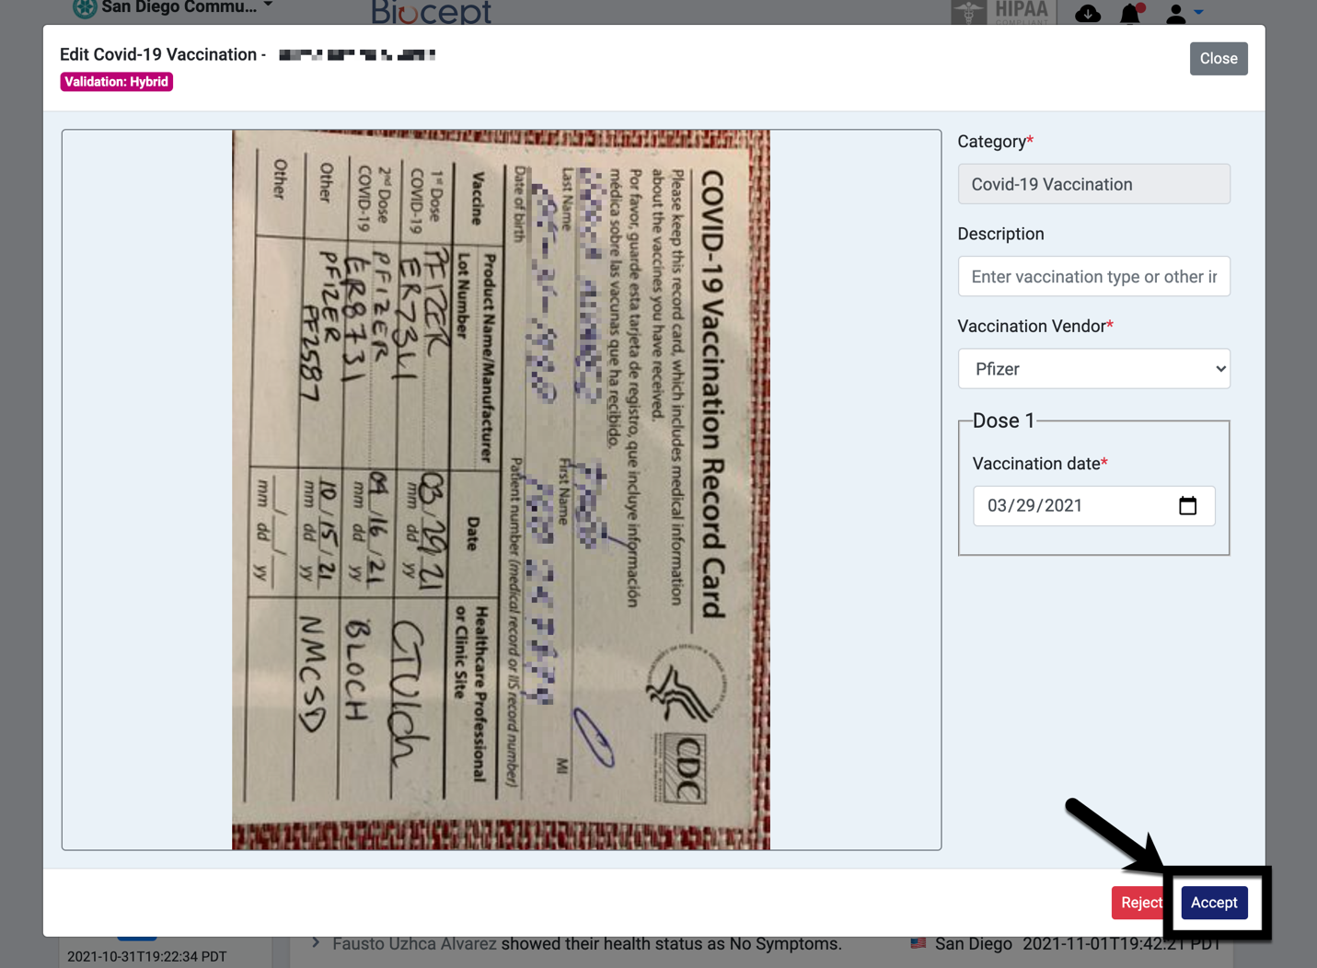
STEP | Instructions
14) | The status for the bottom row now should show “Completed”.
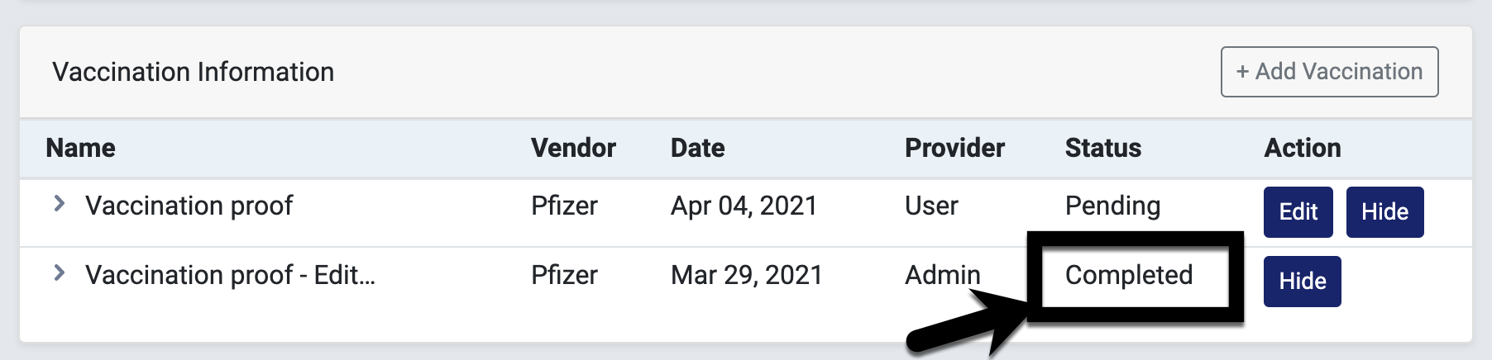
STEP | Instructions
15) | Proceed with the row above by clicking on “Edit”.  (The student will not receive a GreenPass in Biocept/Cleared4 until they show that they are “fully-vaccinated” – two shots after 14 days.)
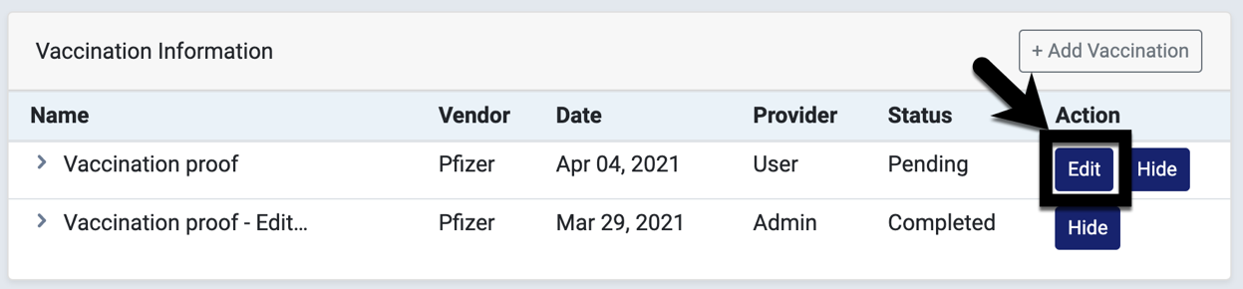

STEP | Instructions
16) | Validate the student’s information, vaccination name, date taken, etc. In this example, Dose 2 is Pfizer and the student entered 04/04/2021. However, this does not match with the Vaccination Card which shows 04/16/2021 for the 2nd Dose.
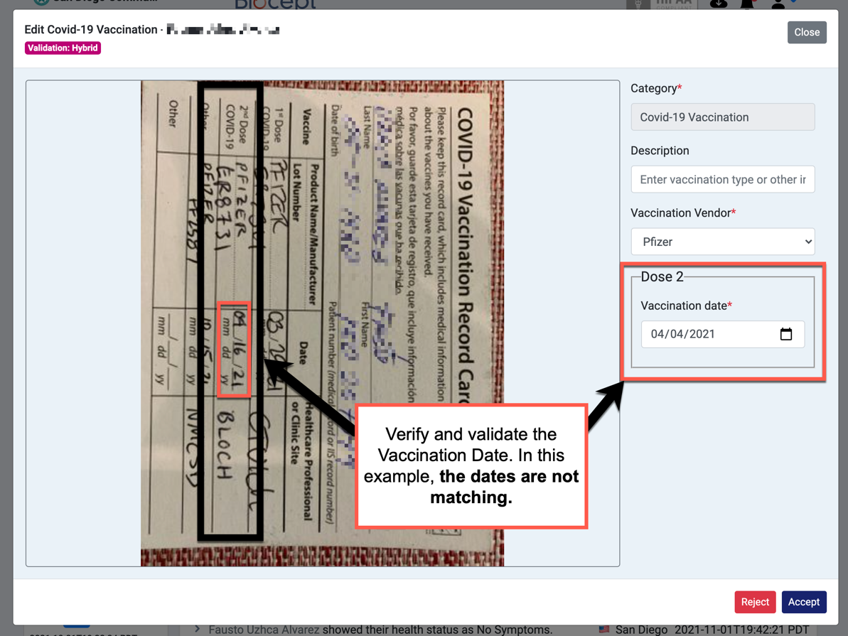
STEP | Instructions
17) | We need to correct the Vaccination Date for Dose 2. Click into the “Vaccination date” field.
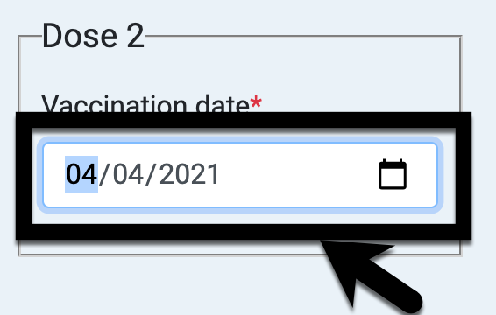
STEP | Instructions
18) | Type in 04/16/2021.
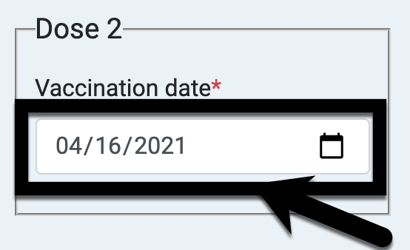

STEP | Instructions
19) | When the correction is complete, click “Accept”.
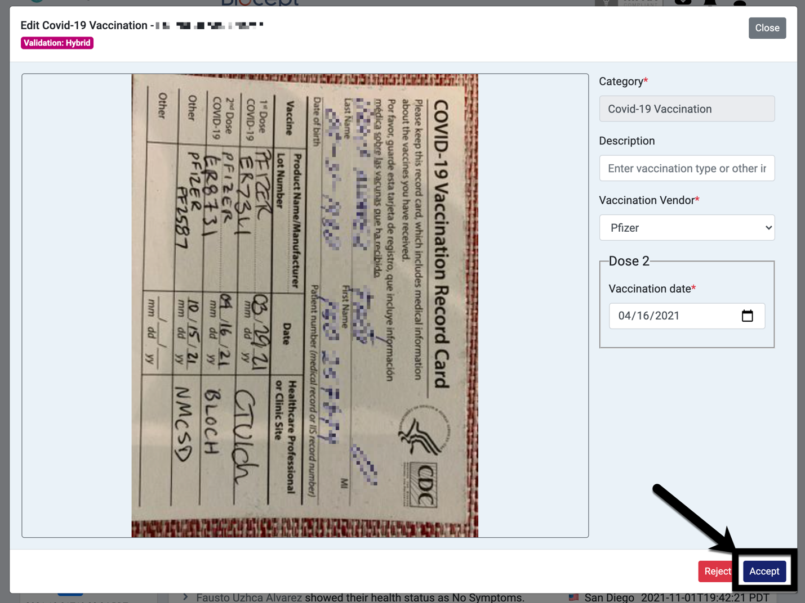

STEP | Instructions
20) | Notice that both rows are now “Completed”, and your student has a “BluePass” now.
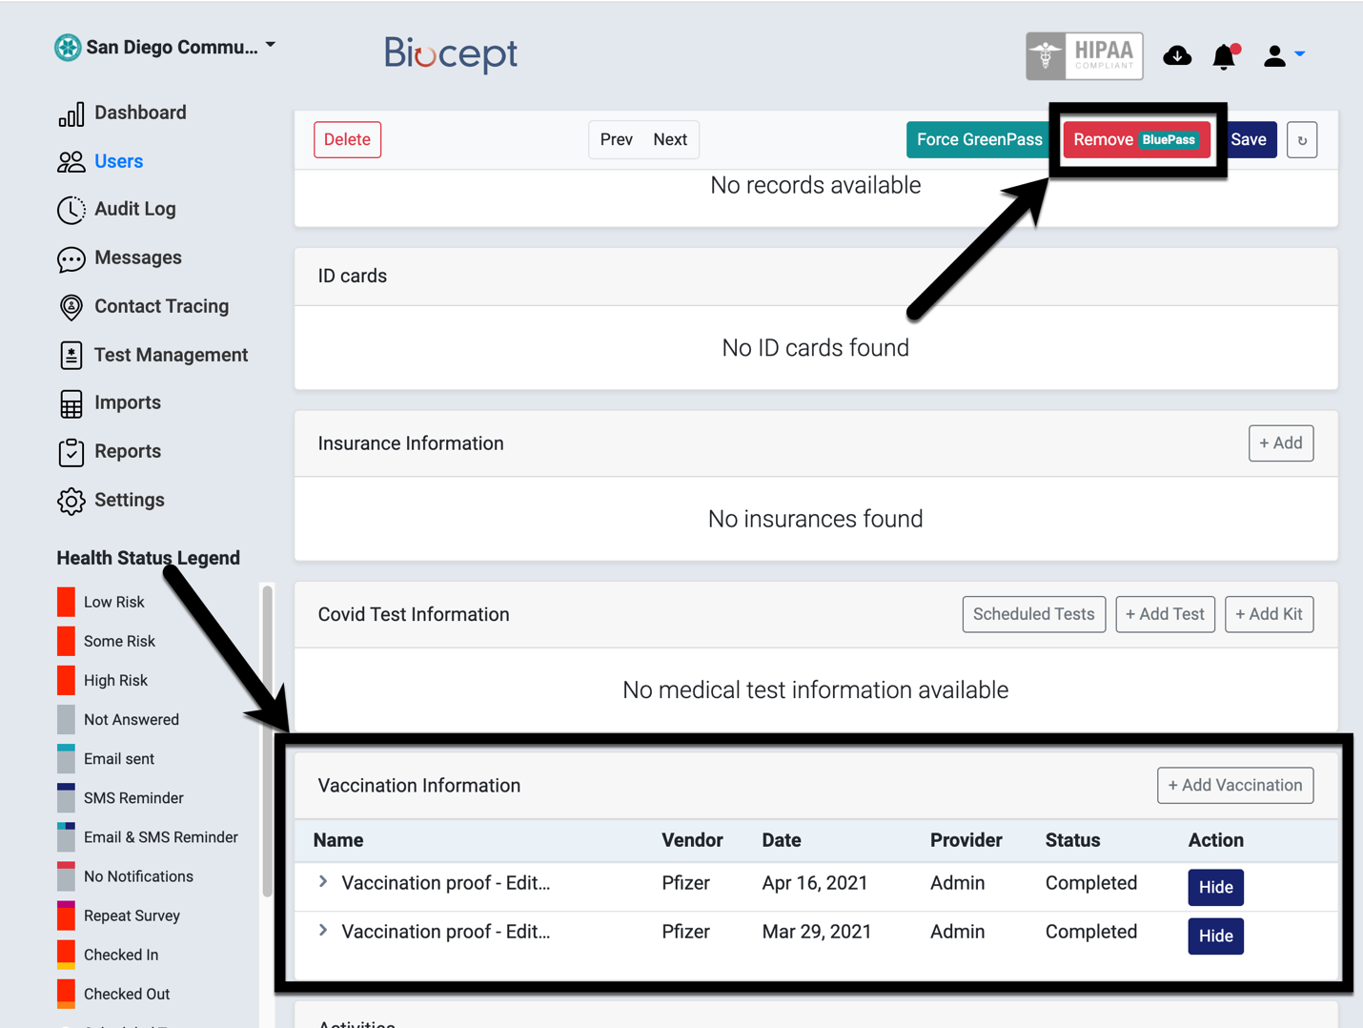

STEP | Instructions
21) | Click on “Users” to return to the previous page and continue with the next student.
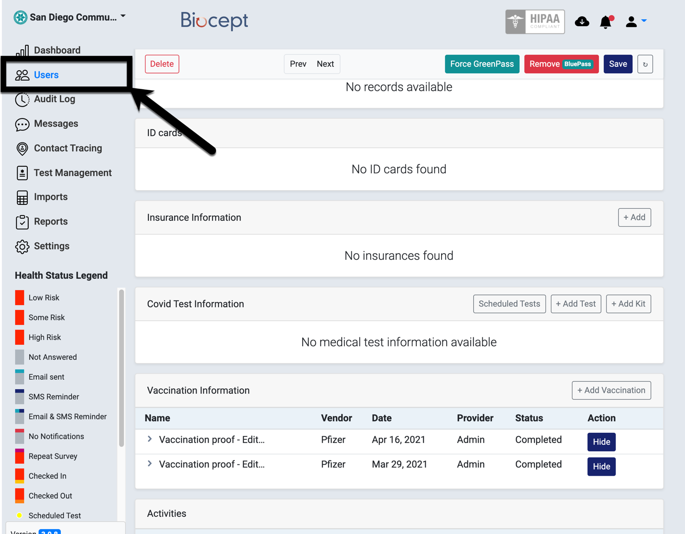

Q: I need to clear registration for a student who only has one vaccine shot.
A: For students with only one vaccine shot, please do the following:

- Add an ACTIVE VAXX student group with an effective date using the current date. (NOTE: Once the term begins, be sure to effective date the student group using the best practice date of 01/01/2022.)
- Add an INACTIVE VAXX student group with an effective date of 02/01/2022.

instructions
STEP | Instructions
1) | After verifying that a student only has one vaccine shot in Biocept/Cleared4 or on their vaccination card, we will add the VAXX student group for the student in Campus Solutions.  Go to Campus Solutions -> Campus Community -> Student Services Center

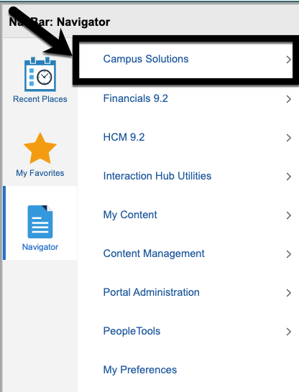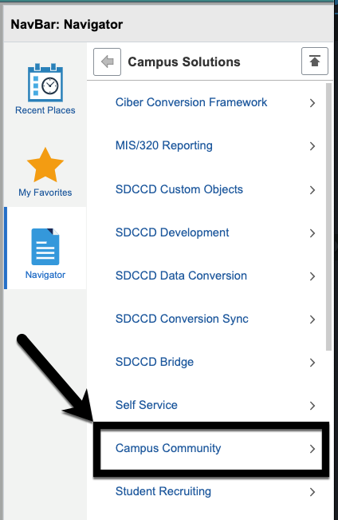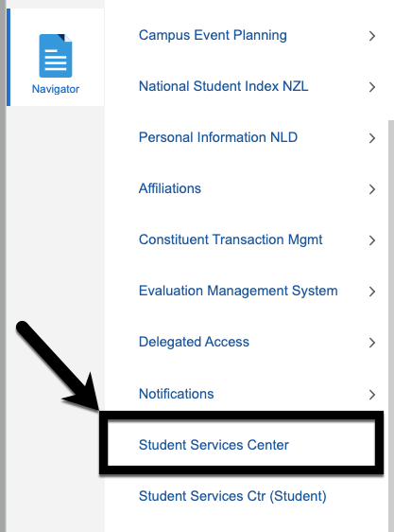

STEP | Instructions
2) | Enter the student ID number in the “ID” field and click “Search”.

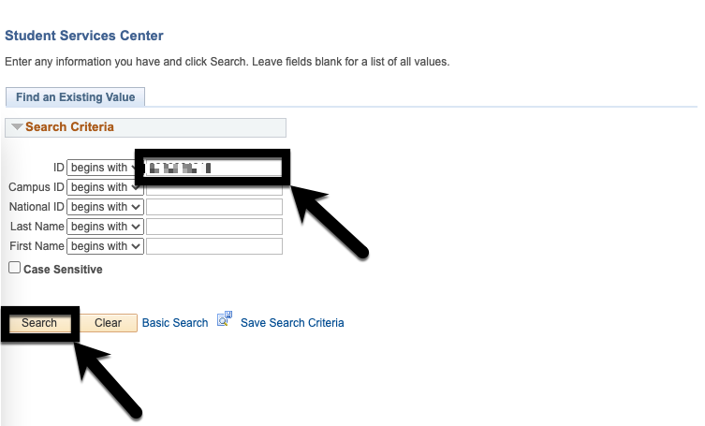

STEP | Instructions
3) | Click on “General Info”.

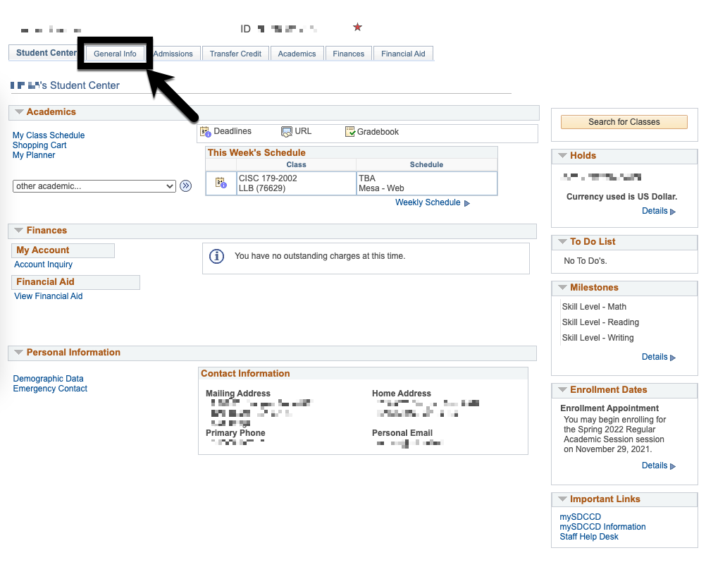

STEP | Instructions
4) | Click on “Edit Student Groups”.

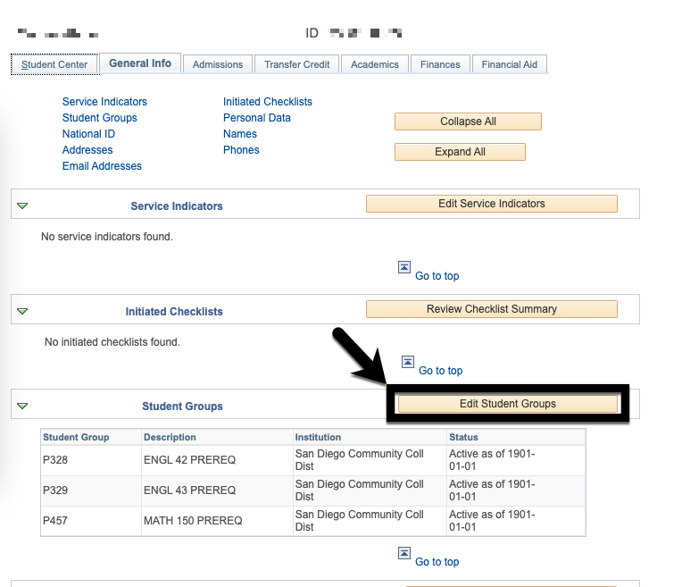

STEP | Instructions
5) | Click on to add a new row.
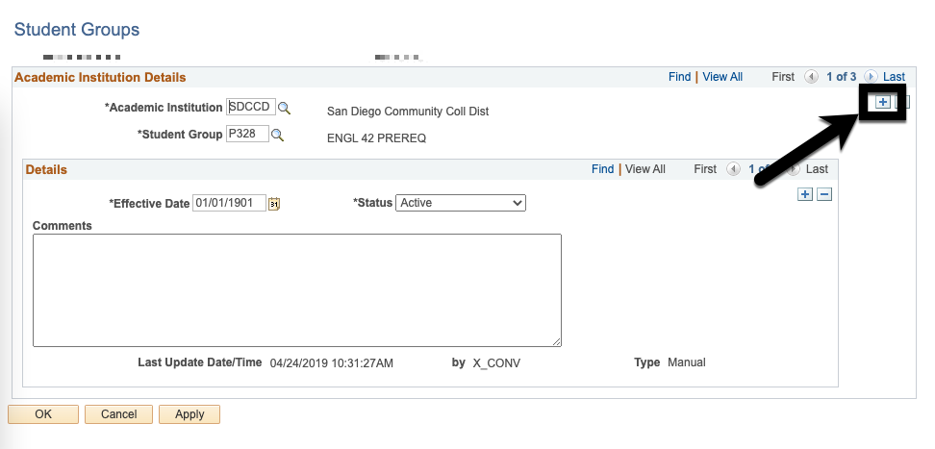

STEP | Instructions
6) | Type in “VAXX” in the “Student Group” field.

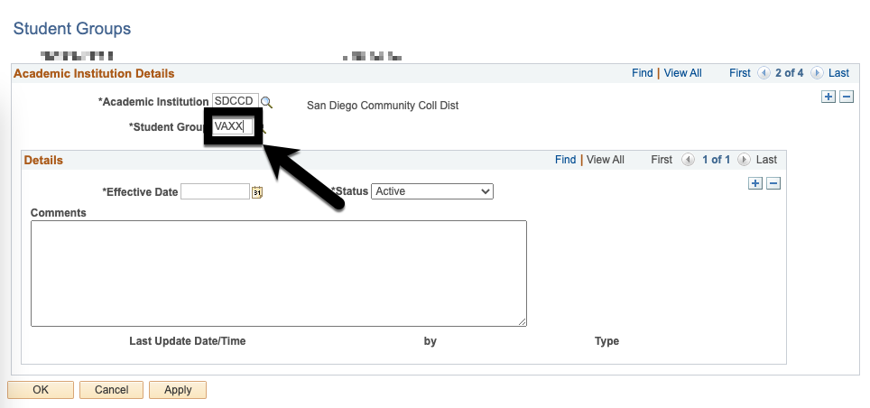

STEP | Instructions
7) | Type in either the current date or 01/01/2022 in the “Effective Date” field.
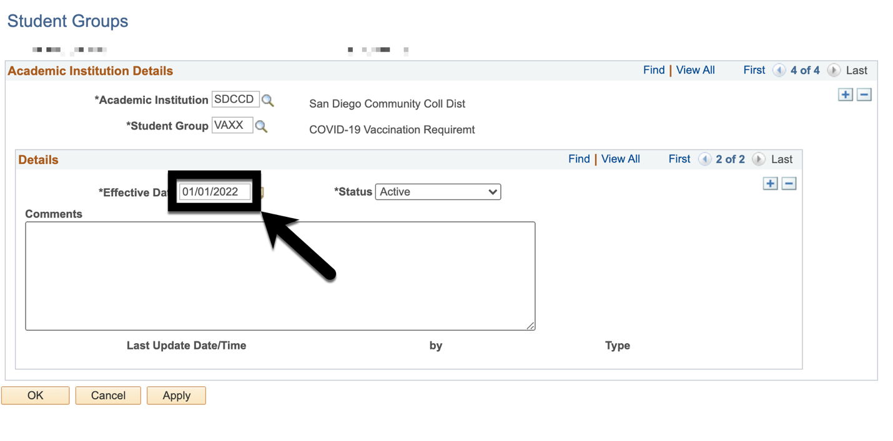

STEP | Instructions
8) | Select “Active” under “Status”.

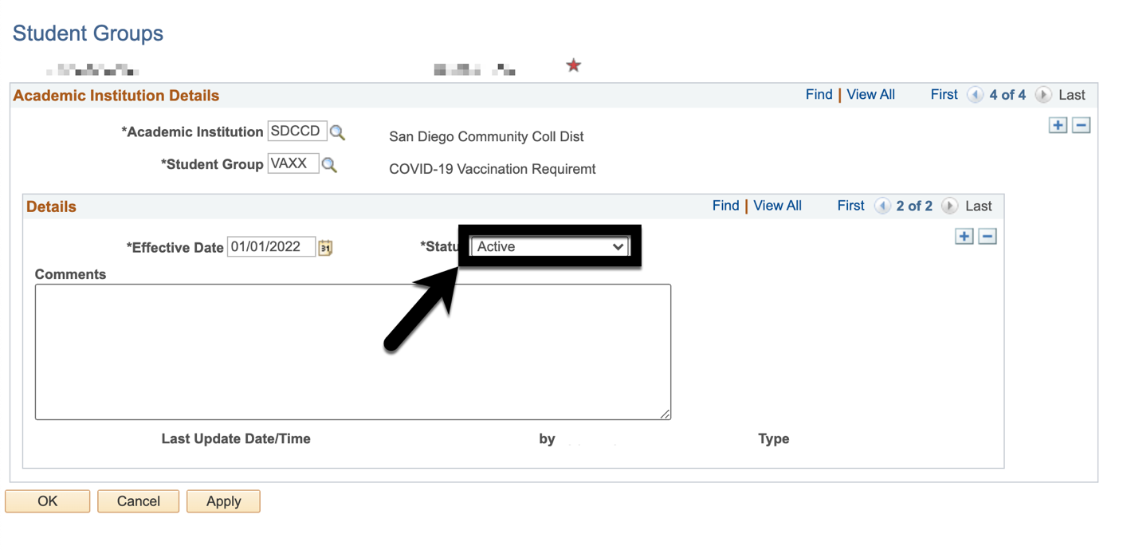

STEP | Instructions
9) | Click on to add a new row.  (NOTE: Ensure that you are clicking on the correct .)

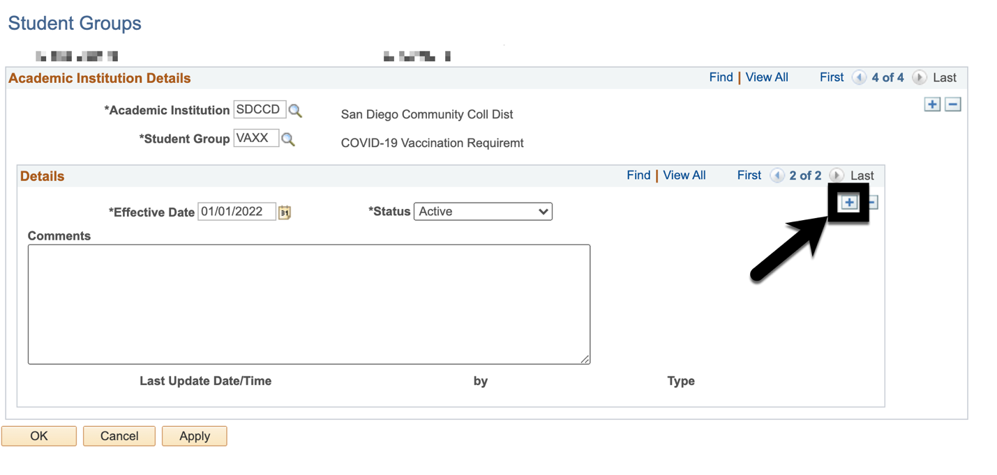
STEP | Instructions
10) | A new row has been added. Notice the row numbers are now 3 instead of 2.
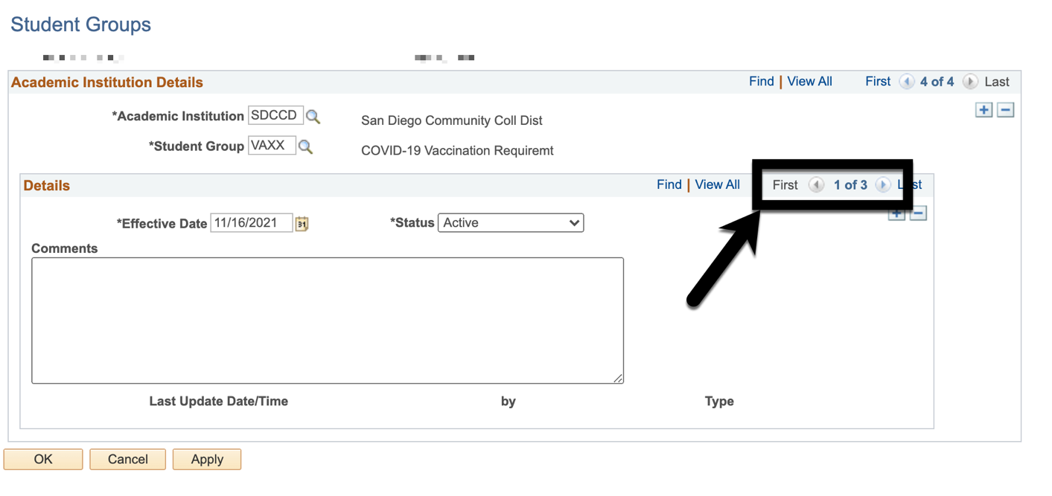
STEP | Instructions
11) | Change the “Effective Date” to 02/01/2022.
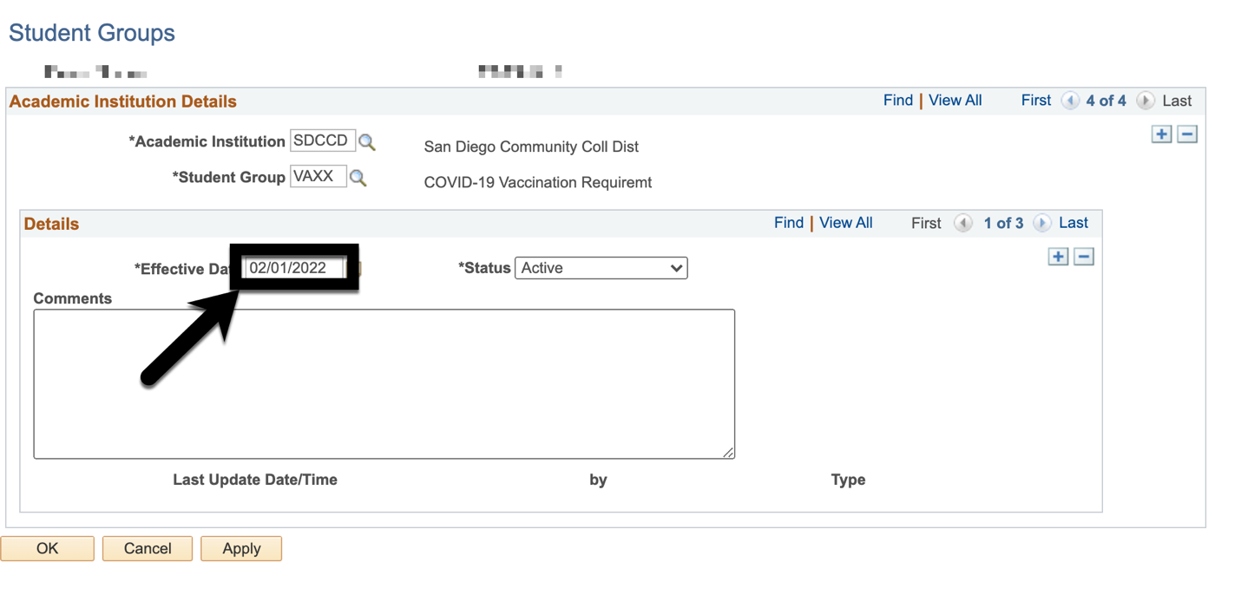
STEP | Instructions
12) | Change the “Status” to “Inactive”.

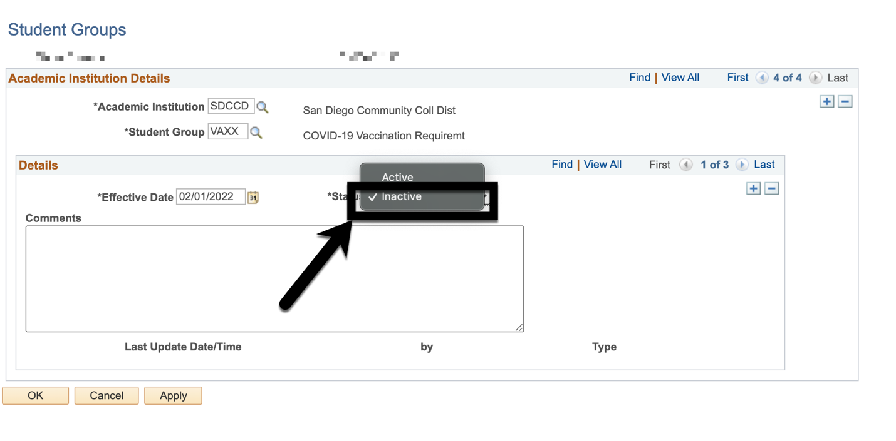

STEP | Instructions
13) | Click “OK”. You have added an inactive row of VAXX student group to the student!
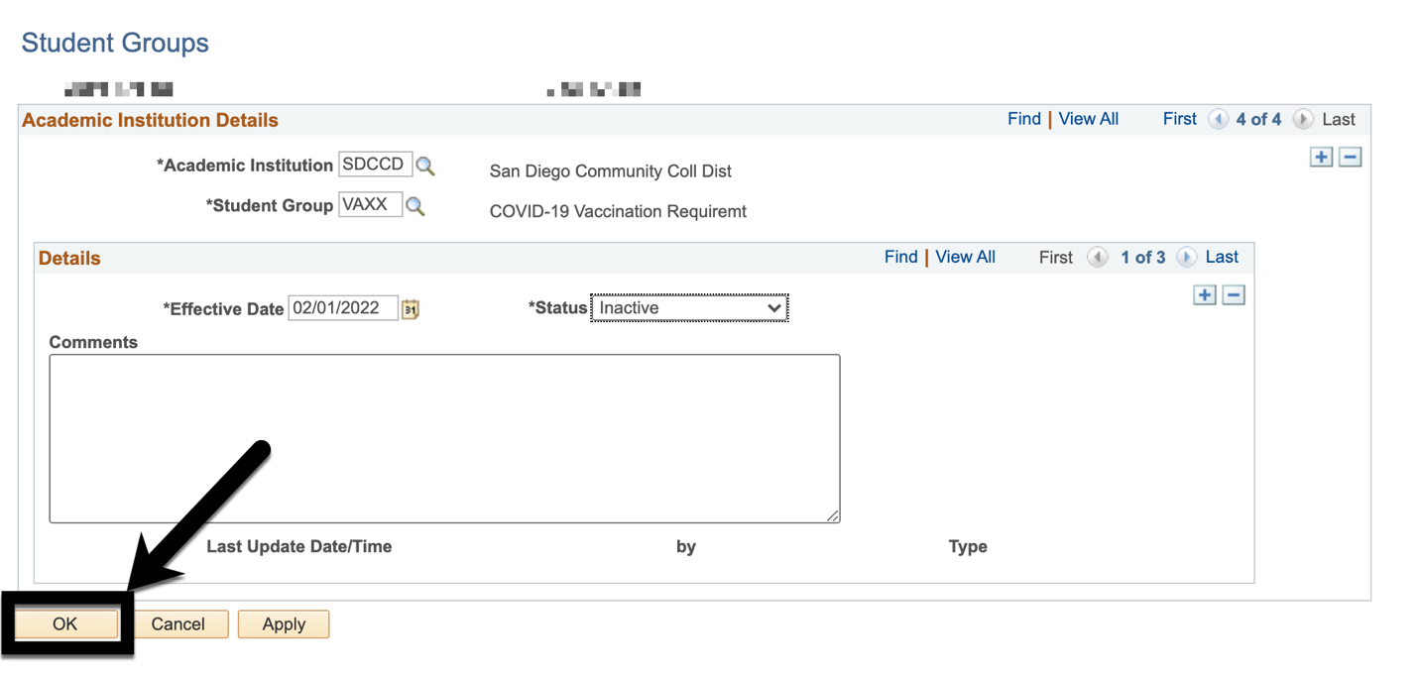

Q: What to do if a student submitted multiple vaccination cards?
A: We need to process (accept OR reject) all of it. Leaving the cards in PENDING status will leave the student in the “Pending VAXS” queue in Cleared4/Biocept.
Example:
